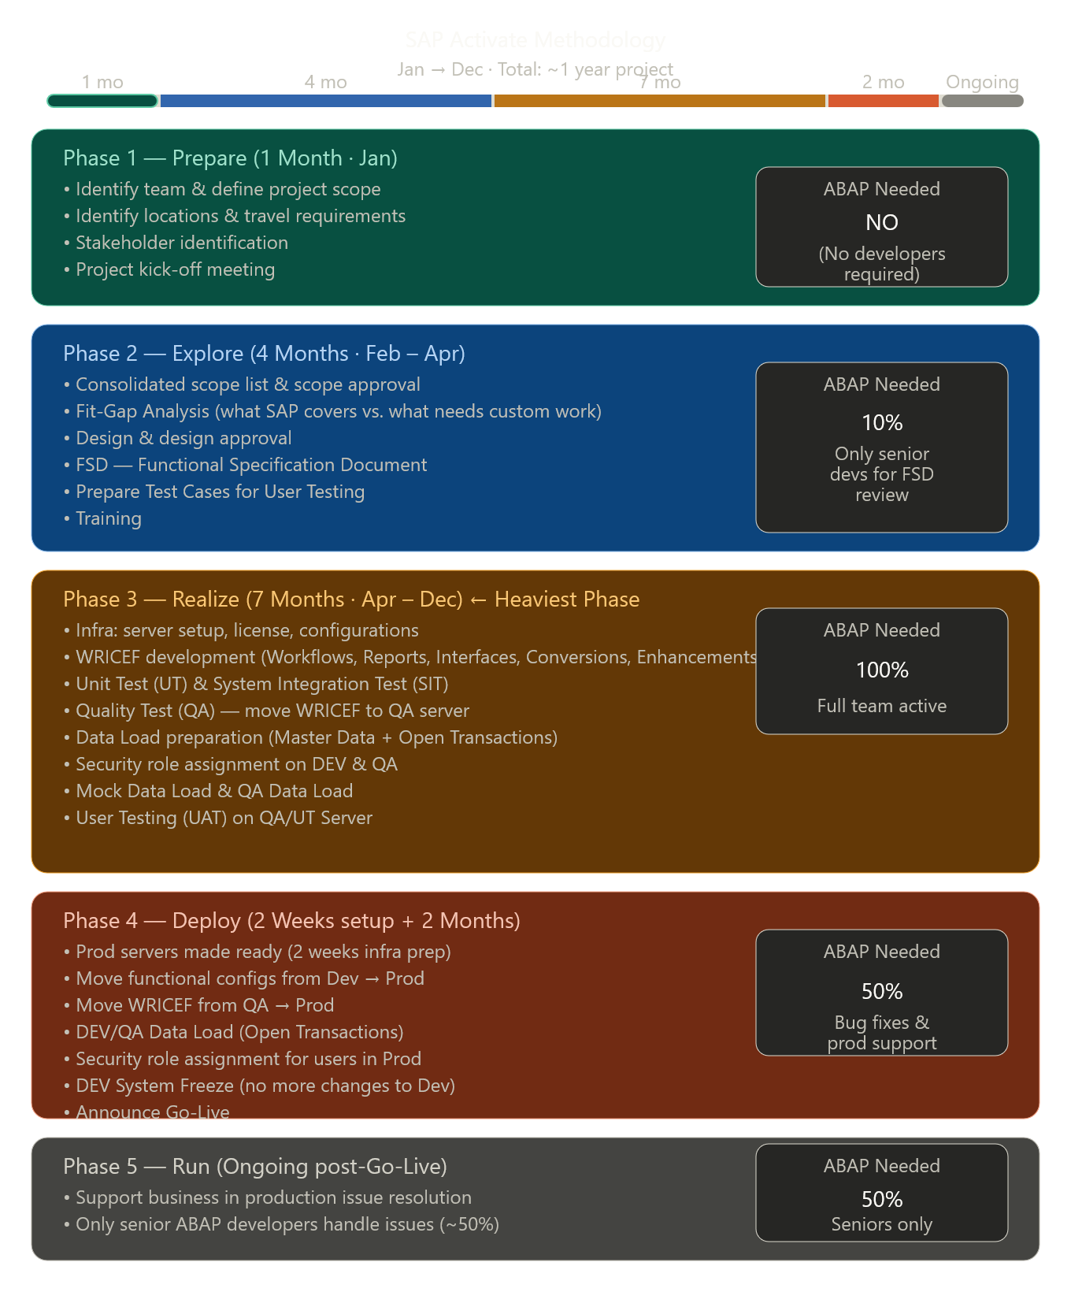
Phase 1 – Prepare (1 month) This is pure planning. No coding at all. You figure out who's on the team, what the project will cover, who the stakeholders are, and you kick off the project officially.
Phase 2 – Explore (4 months) You go deep into understanding what the business needs versus what SAP already offers out of the box. The key output is the FSD (Functional Specification Document) — a detailed blueprint for anything that needs to be custom-built. Only senior ABAP developers are needed here, and only a little (10%).
Phase 3 – Realize (7 months — the biggest phase) This is where all the actual building happens. Developers write WRICEF (custom code for Workflows, Reports, Interfaces, Conversions, Enhancements, Forms). Everything gets tested — Unit Testing → SIT → QA → User Testing (UAT). Data is loaded and roles are set up. ABAP is at 100% capacity here.
Phase 4 – Deploy (about 2 months) The system moves to Production. Configs and custom code migrate from Dev → QA → Prod. Data is loaded into live servers, user roles are assigned, the system is frozen, and Go-Live is announced. ABAP drops to 50% (mostly fixing last-minute issues).
Phase 5 – Run (ongoing) After go-live, the team supports the business if problems arise in production. Only senior ABAP developers handle this — juniors are done.

